1. Basic Data Types in R
Rosenivitha J
192424009
ITA0406 - STATISTICS WITH R PROGRAMMING
Activity program 2- DATA TYPES AND VECTORS

PROGRAM:
a <- 25.5
b <- 25L
c <- "R Programming"
d <- TRUE
e <- 2 + 3i
f <- factor("Male")
print(a)
print(b)
print(c)
print(d)
print(e)
print(f)

OUTPUT:
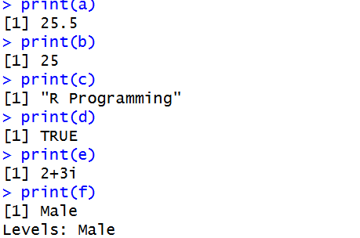

2. Create Variables and Identify Types using class()
PROGRAM:
a <- 25L
b <- 25.5
c <- "R Programming"
d <- TRUE
e <- 2 + 3i
print(a)
print(class(a))
print(b)
print(class(b))
print(c)
print(class(c))
print(d)
print(class(d))
print(e)
print(class(e))

OUTPUT:
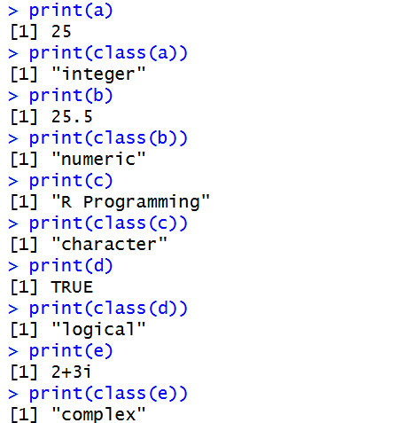

3. Integer and Numeric Data Types
PROGRAM:
a <- 25L
b <- 25.5
print(class(a))
print(class(b))

OUTPUT:
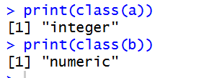
4. typeof(), class(), and is.numeric()
PROGRAM:
x <- 25.5
print(typeof(x))
print(class(x))
print(is.numeric(x))

OUTPUT:
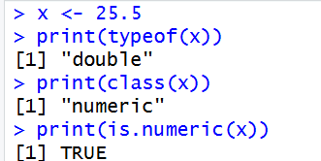

5. Type Conversion
PROGRAM:
a <- 25.5
b <- "100"
x <- as.character(a)
y <- as.numeric(b)
print(x)
print(class(x))
print(y)
print(class(y))

OUTPUT:
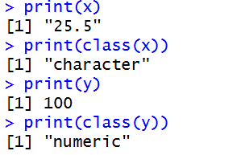
6. Identify Data Types
PROGRAM:
a <- 25L
b <- 25.5
c <- "R Programming"
d <- FALSE
print(class(a))
print(class(b))
print(class(c))
print(class(d))

OUTPUT:
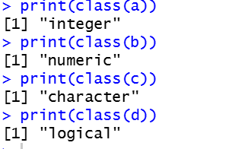

7. Type Coercion
PROGRAM:
x <- c (TRUE, 10, "R")
print(x)
y <- c(TRUE, 10)
print(y)

OUTPUT:
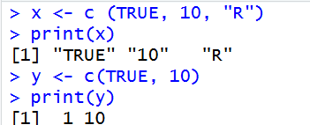
8. Create Numeric, Character, and Logical Vectors
PROGRAM:
x <- c (10, 20, 30)
names <- c ("Ravi", "Anu", "Kiran")
result <- c (TRUE, FALSE, TRUE)
print(x)
print(names)
print(result)

OUTPUT:
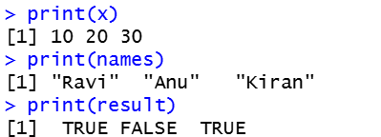

9. Numeric Vector and Arithmetic Operations
PROGRAM:
x <- c (10, 20, 30, 40, 50, 60, 70, 80, 90, 100)
print(x + 5)
print(x - 5)
print(x * 2)
print(x / 2)

OUTPUT:
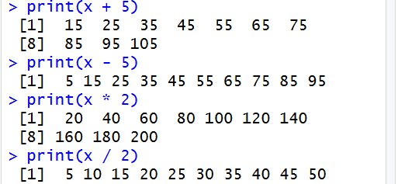
10. Vector Indexing
PROGRAM:
x <- c (10, 20, 30, 40, 50)
print(x[2])
print(x[c(1, 3, 5)])
print(x[-2])

OUTPUT:
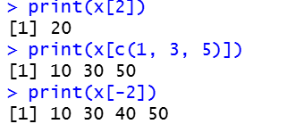

11. Student Marks Operations
PROGRAM:
marks <- c(80, 65, 90, 75, 85, 70)
print(sum(marks))
print(mean(marks))
print(max(marks))
print(min(marks))
print(marks[marks > 75])

OUTPUT:
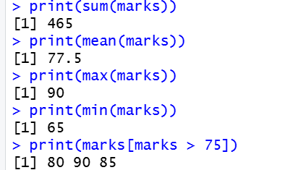

12. Vector Recycling
PROGRAM:
x <- c(10, 20, 30, 40)
y <- c(1, 2)
print(x + y)

OUTPUT:
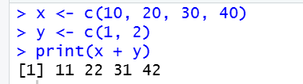

13. Character Vector Operations
PROGRAM:
names <- c("Ravi", "Anu", "Kiran", "Meena", "Arun")
print(sort(names))
print(length(names))
print(names[3])

OUTPUT:
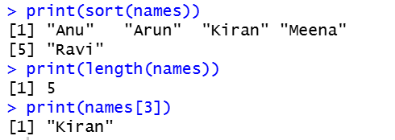

14. Vector Operations – Given Vectors
PROGRAM:
x <- c(10, 20, 30, 40, 50)
y <- c(2, 4, 6, 8, 10)
print(x + y)
print(x * 2)
print(x[c(1, 3, 5)])
print(x[x > 25])

OUTPUT:
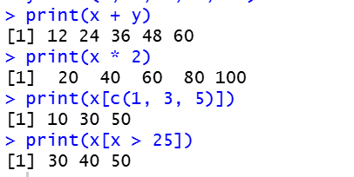

15. Student Attendance Operations
PROGRAM:
attendance <- c (90, 82, 88, 75, 95, 86)
print(attendance[attendance > 85])
print(mean(attendance))
print(sum(attendance > 85))

OUTPUT:
